# 

# 

# 

# PATAN COLLEGE FOR PROFESSIONAL STUDIES

# Assignment 1

# C# Project

# 

# Elevator Controller System

# PROJECT REPORT

# Submitted by Submitted to

# Kshitij Bajagain(1723333) PCPS

# ASSIGNMENT: ELEVATOR CONTROLLER SYSTEM BY USING C#

**Question***>>* The project requires us to program a two-floor office building with an elevator to simulate it. The elevator is made up of a room with a control panel that includes buttons and a display window. There are also request buttons outside each floor.

The elevator doors should open when it arrives at a floor and closes when it departs.

## 

## Initial Design of Application

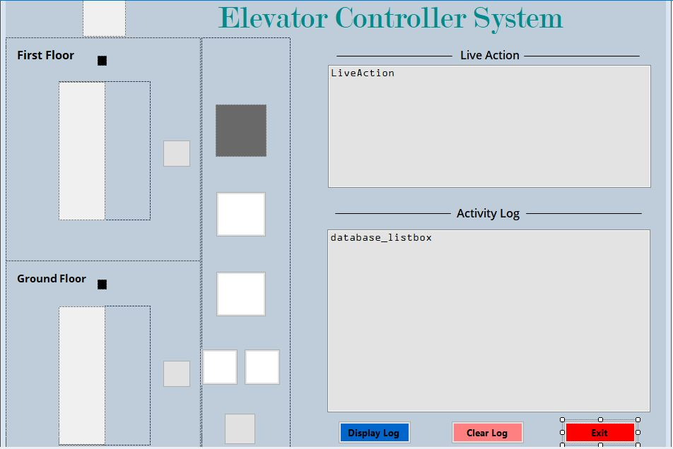

Program:

The program is elaborated down below in branch format:

Form1.cs

#Basic library that was used in this project to make window application

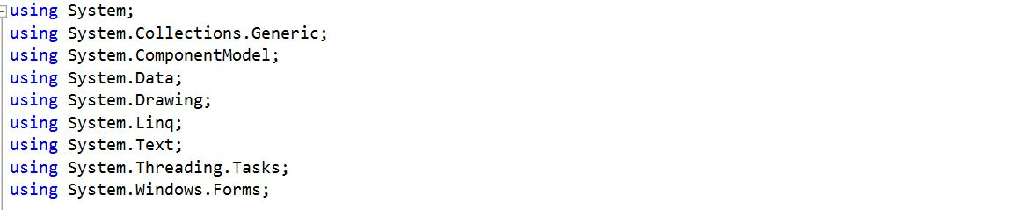

#This code is used to use the library that enables us to us text to speech functions and add voice to our program.



#This code is used to connect the program to a database. 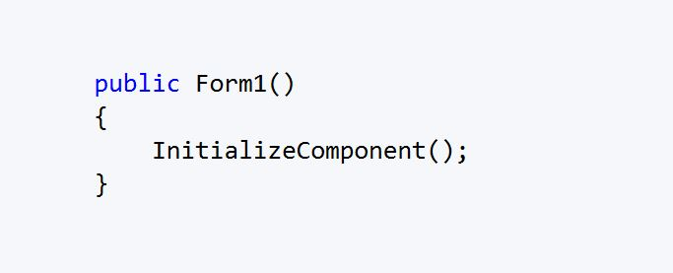

Now, we are all set for coding for our Application .The complete explanation with Screenshots are shown below

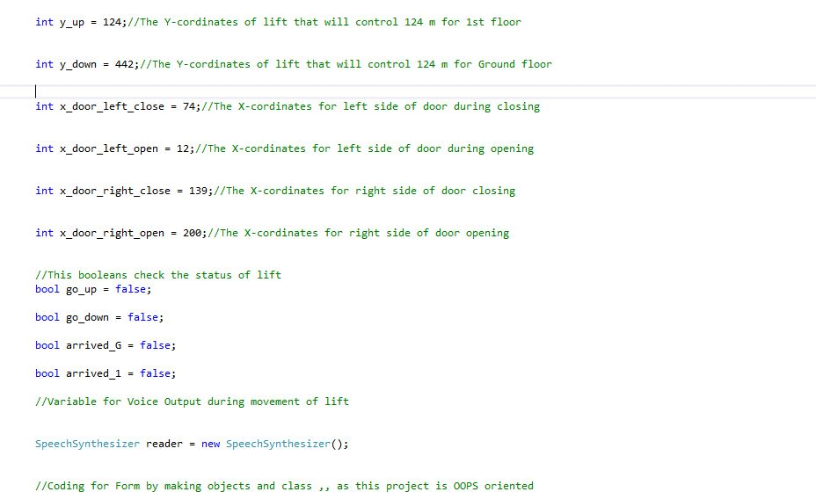

This part of the code instantiates all the variables used in the program.

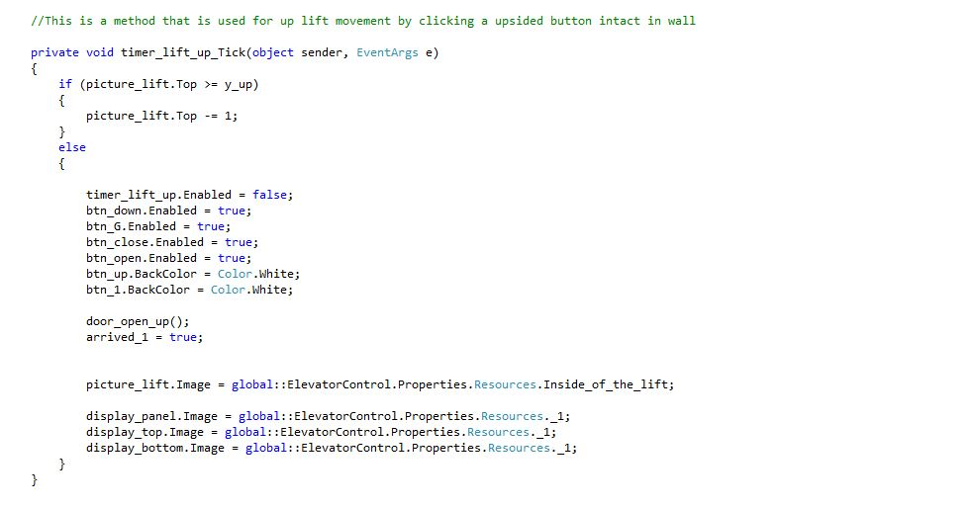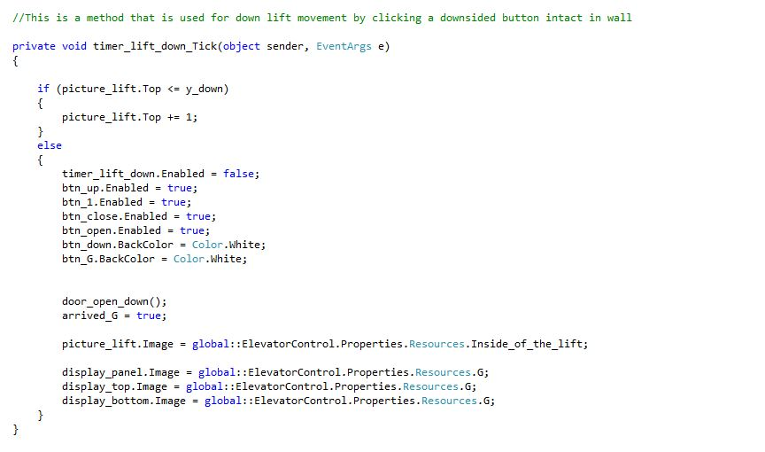These function is called every time the timer interval is over the counties and moves the lift down, similarly it is also used to move lift up when timer runs out of time.

Controllers methods

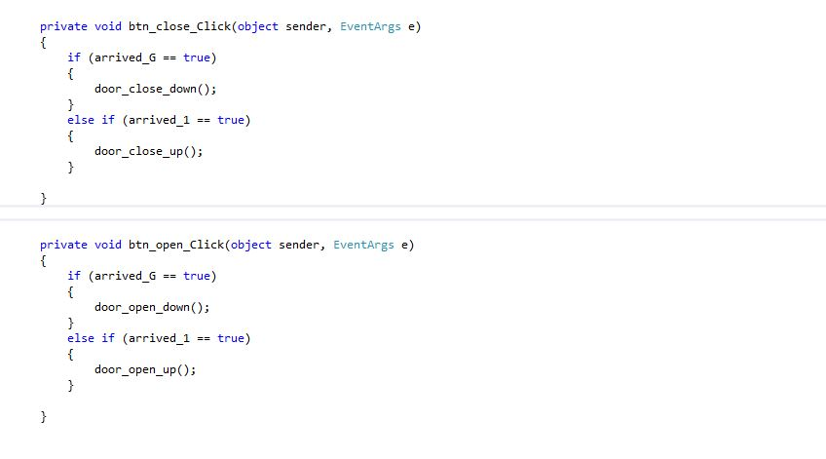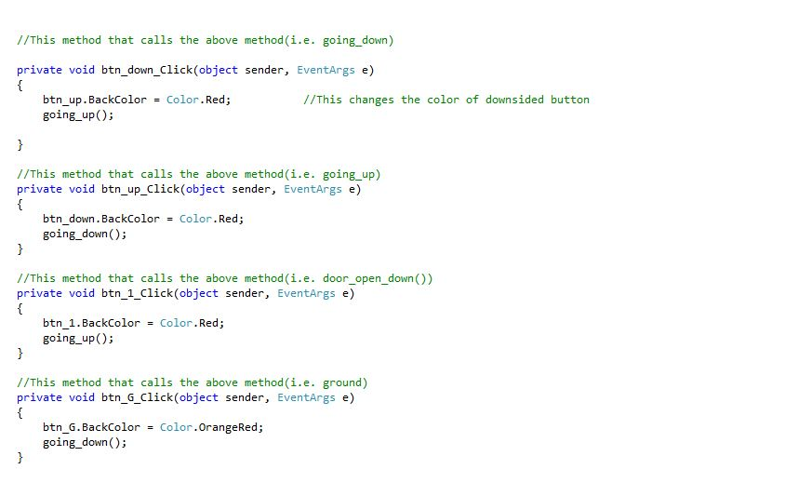

These methods are used by a call-by reference property and they call the functions that are already coded but it is lengthy to show in this documentation(so I haven’t included the screenshot).

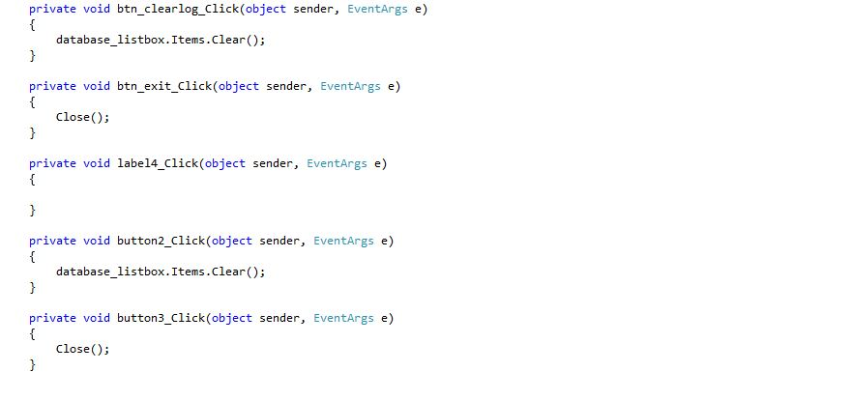

These are the methods which calls the down database codes for displaying and clearing activity log and live action

Database Codes

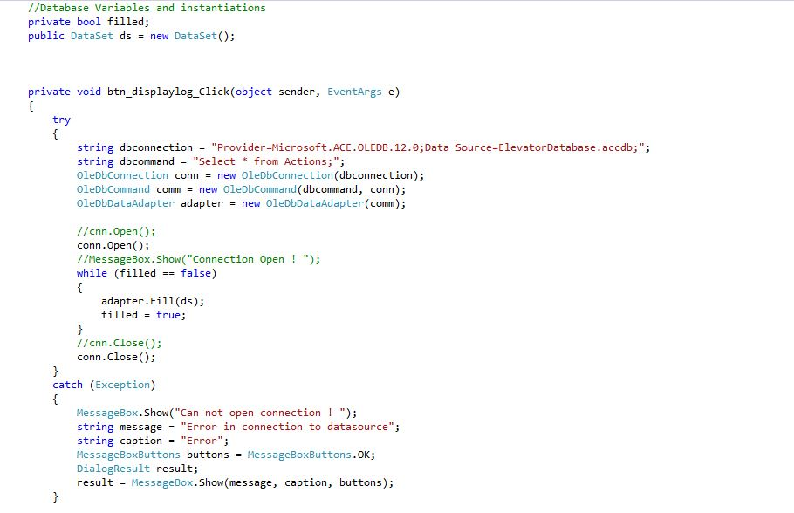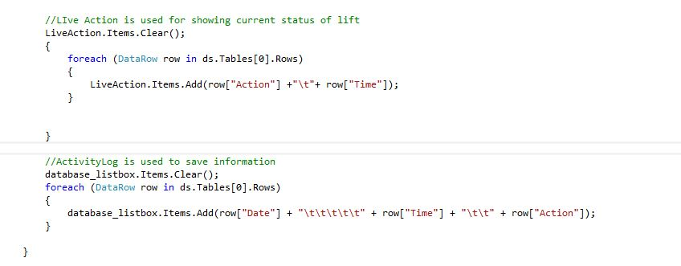

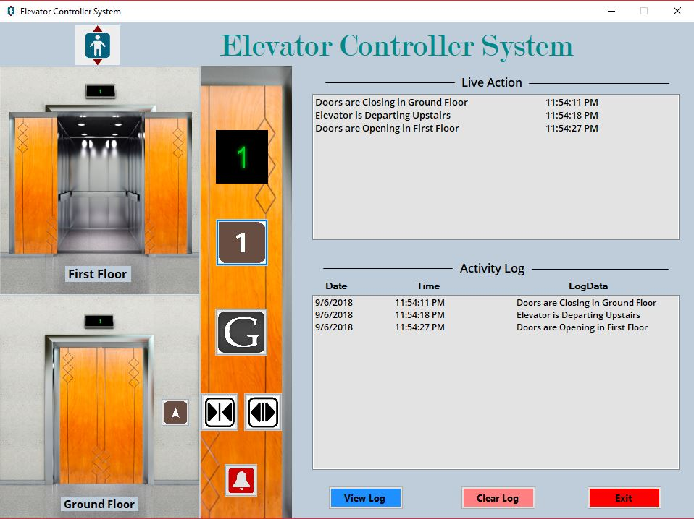

## Testing

The finished program was run with the following operations:

When the program is executed the final product was found as this above.

Individual Reflective Report

Problems that I faced while preparing this applications was in calling methods and making constructor and functioning of those buttons. However it was challenging as well as fun while coding for this Windows Application.I really enjoyed coding during Development.

And further, I want to showcase my coding skills on upcoming projects ..

While wrapping up , I want to show the my class view and object view(Auto Viewer from Visual Studio) which was used during programming of this Elevator Controller System windows application .

## 